Subscription Extrude Rooms to Mass

This add-in is designed to extrude the boundaries of selected rooms as individual mass elements for uses ranging from block and stack workflows to conceptual visualizations. A few of the most notable features include the ability to update existing room mass elements in the model as well as use any parameter you want to drive the materiality of the resulting masses (“Department” values are default).

Contents

The User Form 1

Dynamic Materiality 2

Storing the RFA Files and Purging 2

Sample Demonstration 2

# The User Form

The entire tool is composed of a single user form where rooms can be selected to target the extrusion process. All rooms will be checked as default, so be sure to use the checkboxes to single out the rooms that you want the tool to focus on prior to clicking the “Generate Masses” button.

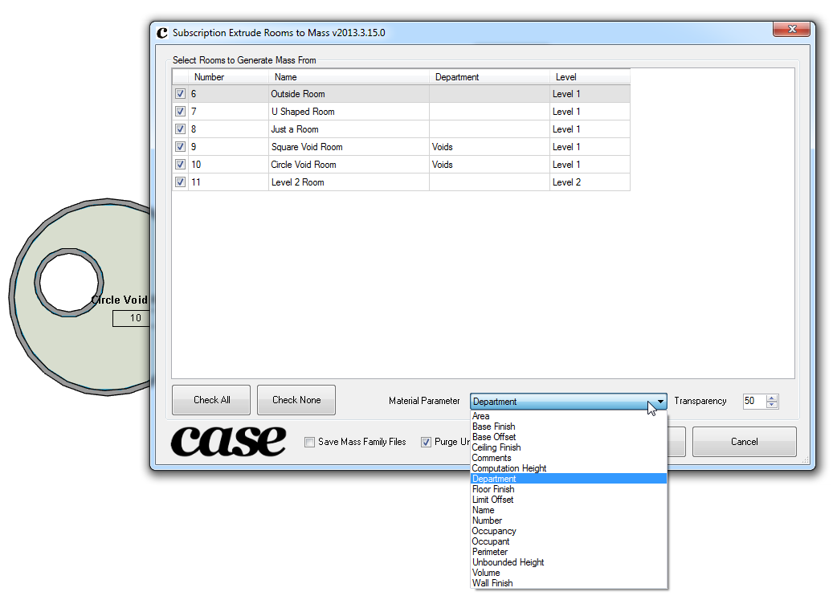

## Dynamic Materiality

You can use any parameter you choose to drive the material assignments for each of the mass elements to be generated. The materials applied with have a prefix of “Mass_Room_” followed by the value of your selected parameter for each room. You also have an option to set the transparency for the materials being applied to the mass elements. The default transparency is 50%.

## Storing the RFA Files and Purging

Options are provided where you can keep the RFA files generated by the tool as well as purge all unused room masses from the model.

# Sample Demonstration

The sample model used to illustrate a few odd room conditions such as internal voids and circular boundary walls is used to test the model extrusion process.

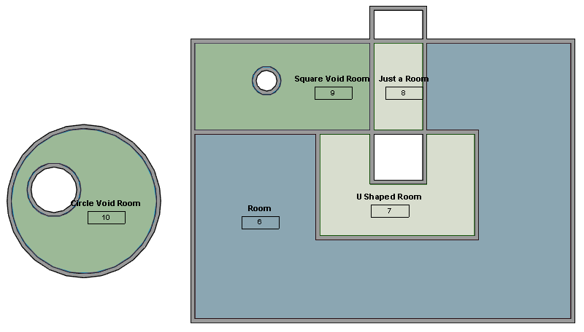

The resulting mass extrusions are illustrated below. Notice how the room voids are respected in the room mass elements and each room’s color is being driven by the department value. You can edit the coloring for the mass element materials to match what you may have in a color fill legend applied somewhere else in your model.

